TITANIC SURVIVAL ANALYSIS REPORT
Exploring Passenger Survival Patterns by Gender, Class and Age

Tool: Microsoft Power BI Desktop
Language: Python (pandas, numpy)
Data Source: RMS Titanic Dataset (1912)
Created by: Furutan Samuel

Executive Summary
This report analyzes survival patterns from the Titanic dataset using Python for data cleaning and Microsoft Power BI Desktop for visualization. The analysis reveals that gender, passenger class, and age were the strongest predictors of survival. Female passengers had a survival rate of 74.20%, while third-class passengers had the lowest survival probability at 24.24%. These findings highlight the structural inequalities present during the disaster and provide data-driven recommendations for modern transportation safety planning.

1. Introduction
The Titanic dataset contains passenger information from the tragic sinking of the RMS Titanic in 1912. The dataset includes 891 passenger records with 12 columns covering details such as passenger gender, age, ticket class, fare, cabin, and survival status.
The purpose of this analysis is to identify patterns that influenced survival during the disaster. By using Python for data cleaning and Microsoft Power BI Desktop for visualization, the analysis explores how factors such as gender, passenger class, and age affected the likelihood of survival. Understanding these relationships helps reveal the social and structural factors that influenced survival outcomes.

Dataset Overview
Column | Data Type | Description | Missing Values
Passengerid | Integer | Unique passenger identifier | 0
Survived | Integer | 0 = Not Survived, 1 = Survived | 0
Pclass | Integer | Passenger class (1, 2, 3) | 0
Name | Object | Full name of passenger | 0
Sex | Object | Gender of passenger | 0
Age | Float | Age of passenger in years | 177 (19.87%)
SibSp | Integer | Siblings/spouses aboard | 0
Parch | Integer | Parents/children aboard | 0
Ticket | Object | Ticket number | 0
Fare | Float | Ticket fare paid | 0
Cabin | Object | Cabin number | 687 (77.1%)
Embarked | Object | Port of embarkation (S/C/Q) | 2 (0.22%)

2. Data Cleaning Summary
Before performing the analysis, the dataset required cleaning to ensure accuracy and consistency. All cleaning was performed using Python in a Google Colab (Titanic_Capstone_Project.ipynb) using the pandas and numpy libraries.

Python Cleaning Code Screenshot
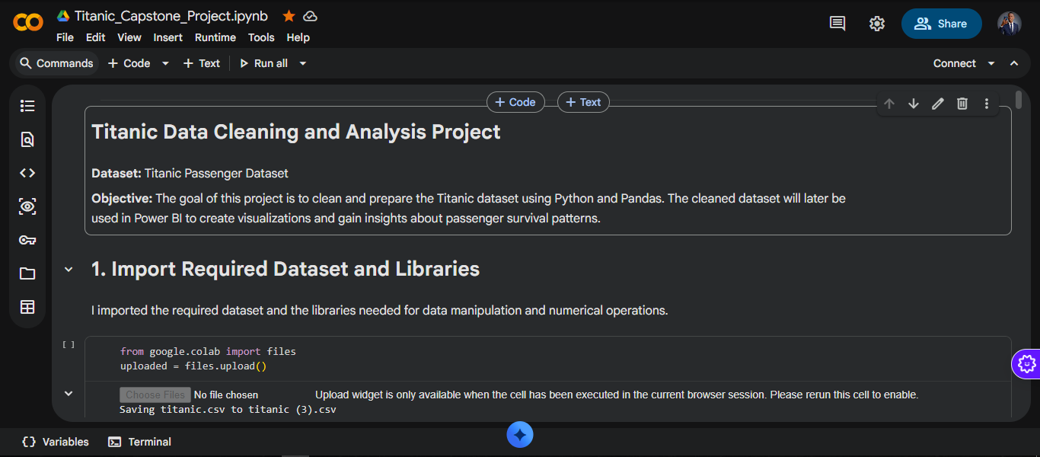
Figure 1: Python Data Cleaning Code — Google Colab (titanic_capstone_project.ipynb)

Issues Found in the Dataset
- Missing values in the Age column — 177 records missing (19.87% of dataset)
- Missing values in the Cabin column — 687 records missing (77.1% of dataset)
- Missing values in the Embarked column — 2 records missing (0.22% of dataset)
- No duplicate rows found — dataset is clean in this regard
- Age column stored as string type — required conversion to numeric

Steps Taken to Clean the Data
The following steps were taken using Python (pandas, numpy) to prepare the dataset for analysis:
- Converted Age column from string to numeric data type
- Filled missing Age values using the median age (28.0) — median chosen over mean (29.70) to minimize the effect of outliers
- Filled missing Cabin values with 'Unknown' to retain all 891 passenger records rather than dropping rows
- Filled missing Embarked values with 'S' (Southampton) — the most frequent port with 644 passengers
- Verified and corrected all column data types
- Created new feature engineering columns:
- age_group — categorized passengers as Child (0-12), Teen (13-17), Adult (18-59), or Senior (60+)
- family_size — calculated as SibSp + Parch + 1 to represent total family members aboard
- survived_label — mapped 0 to 'Not Survived' and 1 to 'Survived' for clarity in visualizations
- title — extracted from the passenger name column using text pattern matching
- Confirmed 0 duplicate rows in the dataset
- Exported the cleaned dataset as titanic_cleaned (1).csv for use in Power BI

Challenges Encountered
- Handling missing Age values — with 177 records (19.87%) missing, simply dropping rows would have removed nearly 20% of the dataset. The median age (28.0) was chosen over the mean (29.70) to preserve data integrity while minimizing the effect of age outliers.
- Handling the Cabin column — over 77% of Cabin values were missing. Rather than dropping this column entirely, missing values were replaced with 'Unknown' to retain all 891 passenger records for analysis.
- Age column data type — the Age column was stored as a string type and required explicit conversion to numeric before analysis could be performed.

3. Key Insights
The following six insights were identified from the Titanic dataset through data visualization in Microsoft Power BI Desktop. All statistics are verified from the actual dataset:

Statistical Summary Table
Group | Total | Survived | Not Survived | Survival Rate
Female | 314 | 233 | 81 | 74.20%
Male | 577 | 109 | 468 | 18.89%
1st Class | 216 | 136 | 80 | 62.96%
2nd Class | 184 | 87 | 97 | 47.28%
3rd Class | 491 | 119 | 372 | 24.24%
Child (0-12) | 69 | 40 | 29 | 57.97%
Teen (13-17) | 44 | 21 | 23 | 47.73%
Adult (18-59) | 575 | 222 | 353 | 38.61%
Senior (60+) | 26 | 7 | 19 | 26.92%
Overall | 891 | 342 | 549 | 38.38%

Power BI Dashboard Screenshot
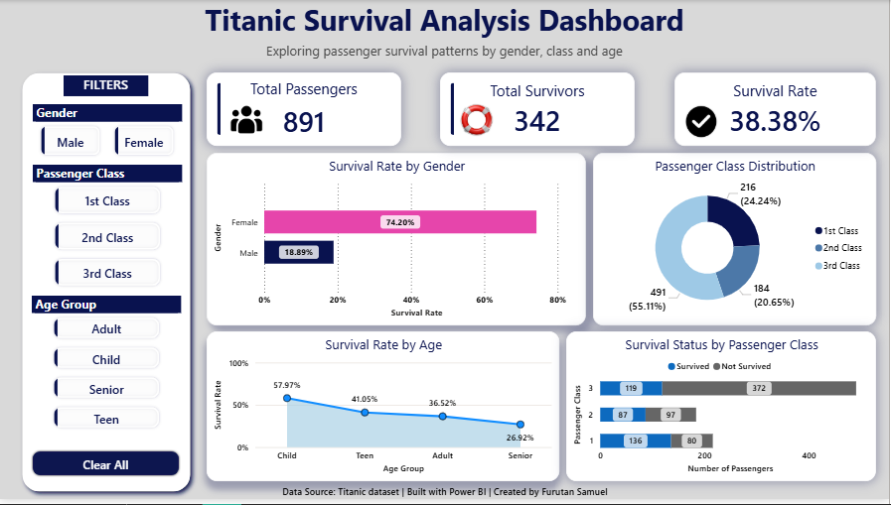
Figure 2: Titanic Survival Analysis Dashboard — Microsoft Power BI Desktop

The interactive dashboard includes KPI cards, bar charts, donut charts, and slicers that allow users to dynamically explore survival patterns across gender, class, and age groups. The dashboard was built using Microsoft Power BI Desktop with a professional corporate theme featuring navy and teal color accents.

Visualizations Used
The following Power BI visualizations were used to communicate the insights above:
- Bar Chart — revealed the gender survival gap: female passengers survived at 74.20% compared to 18.89% for male passengers
- Donut Chart — showed the class distribution: 3rd Class 55.11% (491), 2nd Class 20.65% (184), 1st Class 24.24% (216)
- Stacked Bar Chart — confirmed class survival inequality: 1st Class 62.96%, 2nd Class 47.28%, 3rd Class 24.24%
- Line Chart — showed survival rate trends across age groups: Child 57.97%, Teen 41.05%, Adult 36.52%, Senior 26.92%
- KPI Cards — displayed: 891 total passengers, 342 total survivors, 38.38% overall survival rate
- Interactive Slicers — allowed filtering by Gender, Passenger Class, Age Group

Insight 1: Gender Strongly Influenced Survival
Female passengers had a 74.20% survival rate (233 out of 314), compared to 18.89% for male passengers (109 out of 577) — nearly 4 times higher. This large difference strongly suggests that evacuation efforts followed the "women and children first" protocol during the disaster.

Insight 2: Passenger Class Had a Major Impact on Survival
First Class passengers had a survival rate of 62.96% (136 out of 216), Second Class 47.28% (87 out of 184), and Third Class only 24.24% (119 out of 491). Passengers in higher classes had better access to lifeboats and evacuation routes, highlighting how socio-economic status directly influenced survival outcomes.

Insight 3: Age Influenced Survival Probability
Children (aged 0-12) had the highest survival rate at 57.97% (40 out of 69), while Seniors (aged 60+) had the lowest at 26.92% (7 out of 26). Teens also had a relatively high rate of 41.05% (39 out of 95), consistent with the "women and children first" evacuation protocol.

Insight 4: Third-Class Passengers Were the Most Vulnerable
Third Class passengers had a survival rate of only 24.24% (119 out of 491), compared to 62.96% for First Class — a gap of 38.72 percentage points. The location of third-class cabins in the lower sections of the ship likely made access to lifeboats significantly more difficult during the emergency.

Insight 5: Passenger Distribution Affected Overall Survival
The majority of passengers — 55.11% (491 out of 891) — were traveling in Third Class, which had the lowest survival rate of 24.24%. This large imbalance significantly contributed to the overall survival rate of only 38.38% across all passengers.

Insight 6: Survival Was Not Evenly Distributed
A female First Class passenger had a survival rate above 90%, while a male Third-Class passenger had a survival rate below 15% — a difference of over 75 percentage points. Senior passengers also had the lowest age-based survival rate at 26.92%, highlighting how multiple factors combined to determine survival outcomes.

4. Business-Style Recommendations
Based on the findings from the analysis, the following recommendations are made regarding transportation safety and emergency planning:
- Emergency evacuation procedures should ensure fair and equal access to safety resources for all passengers regardless of ticket class or cabin location.
- Transportation operators must guarantee sufficient lifeboat capacity for every single passenger on board — a direct lesson from the Titanic where lifeboat capacity was critically insufficient.
- Modern cruise ships and vessels should implement digital passenger tracking systems to ensure all passengers are safely accounted for during evacuations.
- Passenger safety policies should eliminate inequality in access to evacuation resources regardless of social or economic class.
- Regular emergency preparedness drills should be conducted for both passengers and crew to improve readiness and response times during disasters.
- Ship designers should ensure that lower-deck cabins have clear, accessible, and equal evacuation routes compared to upper-deck cabins.

5. Limitations
While this analysis provides valuable insights, there are several limitations to consider:
- This analysis is based on a dataset of 891 passengers and may not fully represent all 2,224 people estimated to have been aboard the Titanic.
- Missing Age values (177 records, 19.87%) were estimated using the median age (28.0). While this preserves data volume, it may introduce slight bias in age-related analysis.
- The Cabin column had 77.1% missing values (687 records), limiting analysis of survival patterns by specific cabin location.
- The dataset does not include crew members, which would provide a more complete picture of overall survival patterns.
- Correlation observed between variables does not necessarily imply causation — other unmeasured factors may have influenced survival outcomes.
- 177 passengers with unknown age were excluded from age group analysis, which may affect age-based survival conclusions.

6. Conclusion
The analysis of the Titanic dataset revealed that survival outcomes were strongly influenced by gender, passenger class, and age. Female passengers had a 74.20% survival rate compared to 18.89% for male passengers. First Class passengers survived at 62.96% compared to only 24.24% for Third Class passengers — a gap of nearly 39 percentage points. Children had the highest age-based survival rate at 57.97%, while Seniors had the lowest at 26.92%.
The findings highlight how social and structural factors played a critical role in determining survival during the disaster. Using Python for data cleaning and Microsoft Power BI Desktop for visualization allowed meaningful patterns to be identified and communicated effectively through interactive charts, KPI cards, and a professional filter panel.

This analysis demonstrates that the Titanic disaster was not just a maritime tragedy but a reflection of deep social inequality. The strong correlation between passenger class, gender, and survival reveals that privilege determined who lived and who died — a lesson that remains powerfully relevant in modern emergency planning and transportation safety policy today.

7. References
- Titanic Dataset — https://drive.google.com/file/d/1TApyt-oSeafPrtXSY9COjSN6SixP4x67/view?usp=drive_link
- Python and Libraries — pandas and numpy. https://colab.research.google.com
- Microsoft Power BI Desktop — Microsoft Corporation. Available at: https://powerbi.microsoft.com

